After the quarantine period we took on different small projects in one project we tried to bring a modification to a driller machine which had a minimal safety issue while drilling meaning while drilling a metal a worker has to hold the metal to be drilled with one hand and control the vertical motion of the drill which was unsafe to operate as the metal being drilled could easy slip from the worker hand and cause a harm so we tried to bring solution for it, and that was our first small project so for the idea to be tested we first needed to make a design of what type of mechanism could be installed, so for the design we used Solid works and tried to design every single components and considering it was going to be made by us we tried to build them using scrap metals we could find thanks to Mr. Tilahun finding scraps were a lot easier as they helped us while doing so and next we tried to implement some of the welding and grinding experiences we gained to do our project. We even considered to add a water pouring mechanism which was aimed to reduce the man power needed to operate from two persons to one but was halted as we were engaged in different work so we stopped with only building the clamping mechanism.

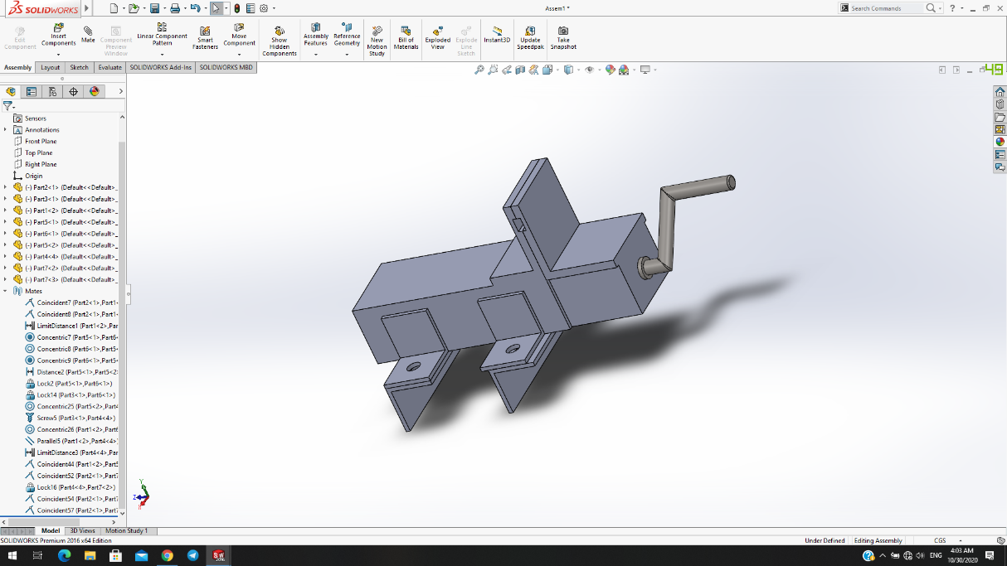 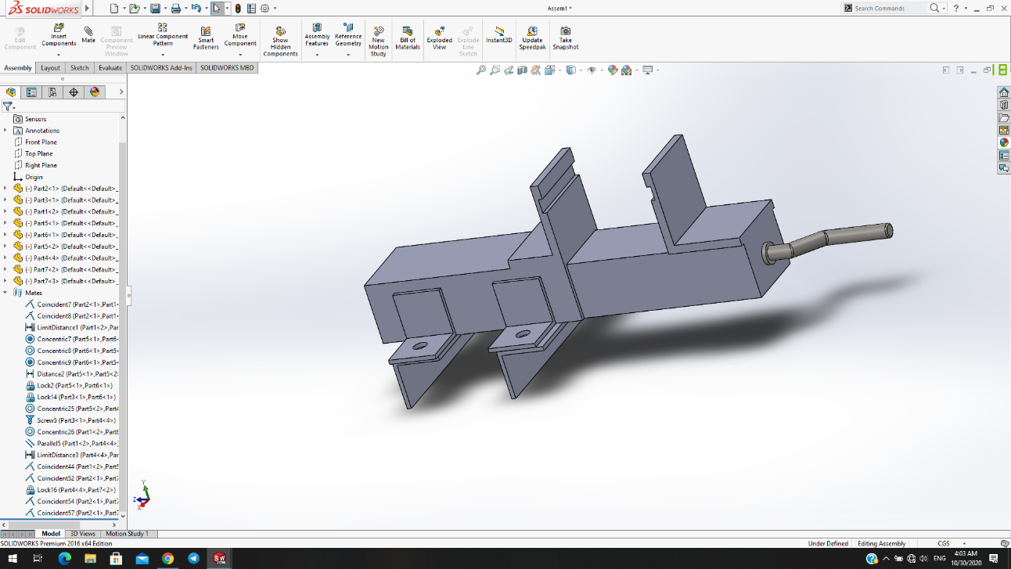

*Fig. A clamping mechanism for a drilling machine*

Lastly in addition to making our automated project we came up with this idea that has same function of seed sowing but that operates mechanically since most of the customers of Electro mecce if not all, would become familiar with the operation of the machine. This machine is supposed to have very less cost. This planter is very simple to use hence, unskilled farmer is able to handle this machine. We simplified the design also made it cheaper and affordable to every rural farmer. The machine is fully mechanical as the customers of the company and most farmers are using the traditional way of planting the goal is to make the machine easy to use and apply in any given field. The machine can be manufactured using different types of metals and a belt is used to couple the shaft of the wheels with a seed sowing mechanism while operation, so as an idea we tried to layout a design of the machine. And for the design we used Solid works as it had lots of features which made it best suited for our work and also while doing the project we were able to further understand how to use the software and implement it in a design process so overall we tried to make a base idea of a new project for the company which they can modify and upgrade to there desire and for us that is a small way of showing gratitude for their support and for us it was a great step toward adapting the design, build and assembly process of a project.

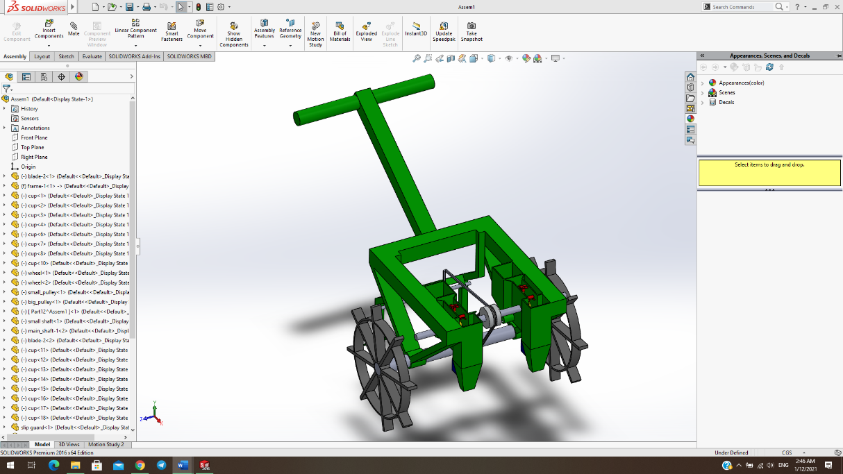 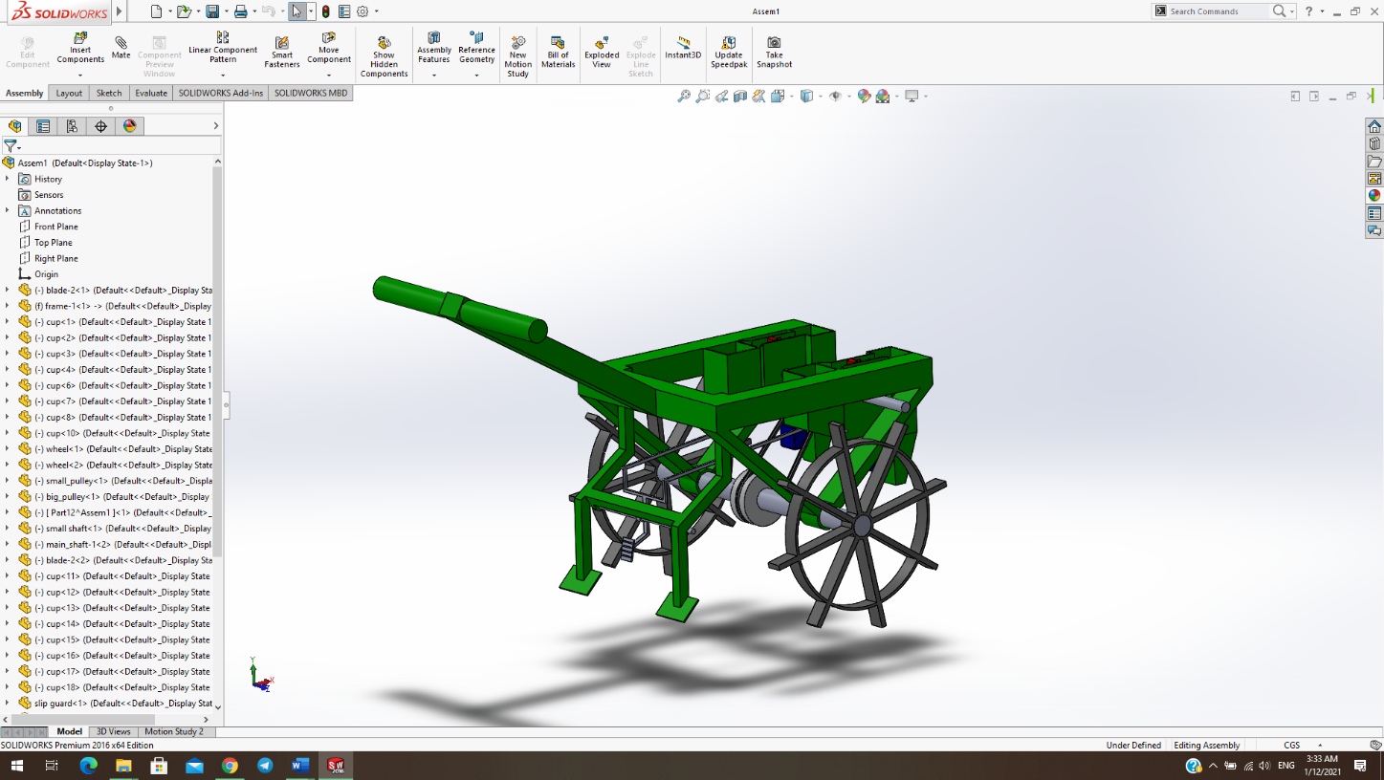

*Fig. A fully mechanical seed sowing machine*